SQL PORTFOLIO PROJECT
TESTING TABLEAU/ POWER BI REPORTS IN SQL
by Ekaterina Khamyshkeeva
Create Table:
create table hrdata
(
emp_no int8 PRIMARY KEY,
gender varchar(50) NOT NULL,
marital_status varchar(50),
age_band varchar(50),
age int8,
department varchar(50),
education varchar(50),
education_field varchar(50),
job_role varchar(50),
business_travel varchar(50),
employee_count int8,
attrition varchar(50),
attrition_label varchar(50),
job_satisfaction int8,
active_employee int8
)

Import Data in Table Using Query:
COPY hrdata FROM 'C:\Users\тс\Desktop\Projects\Complete Project\SQL' DELIMITER ',' CSV HEADER;

Employee Count:
select sum(employee_count) as Employee_Count from hrdata;

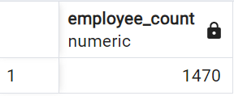

Attrition Count:
select count(attrition) from hrdata where attrition='Yes';
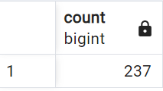

Attrition Rate:
select
round (((select count(attrition) from hrdata where attrition='Yes')/
sum(employee_count)) * 100,2)
from hrdata;
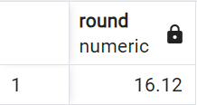

Active Employees:
select sum(employee_count) - (select count(attrition) from hrdata where attrition='Yes') from hrdata;
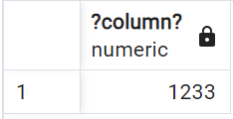

Average Age:
select round(avg(age),0) from hrdata;
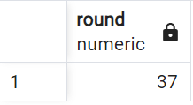

Attrition by Gender:
select gender, count(attrition) as attrition_count from hrdata
where attrition='Yes'
group by gender
order by count(attrition) desc;
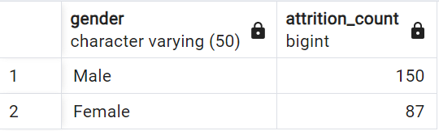

Department Wise Attrition:
select department, count(attrition), round((cast (count(attrition) as numeric) /
(select count(attrition) from hrdata where attrition= 'Yes')) * 100, 2) as pct from hrdata
where attrition='Yes'
group by department
order by count(attrition) desc;
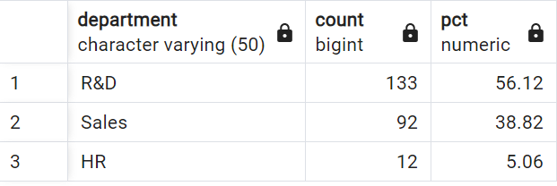

No of Employees by Age Group:
select age, sum(employee_count) as employee_count from hrdata
group by age
order by age;
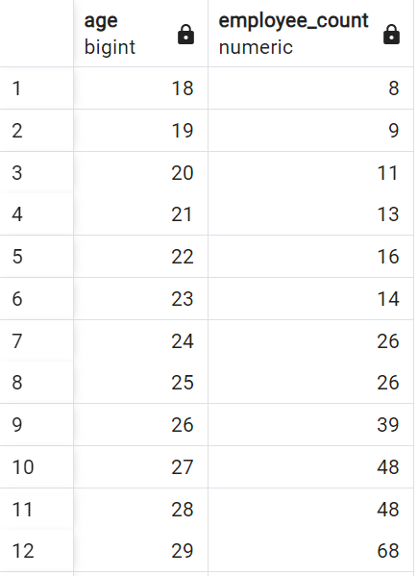
...
Education Field Wise Attrition:
select education_field, count(attrition) as attrition_count from hrdata
where attrition='Yes'
group by education_field
order by count(attrition) desc;
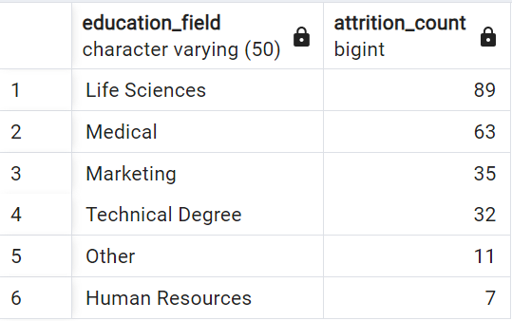

Attrition Rate by Gender for Different Age Groups:
select age_band, gender, count(attrition) as attrition,
round((cast(count(attrition) as numeric) / (select count(attrition) from hrdata where attrition = 'Yes')) * 100,2) as pct
from hrdata
where attrition = 'Yes'
group by age_band, gender
order by age_band, gender desc;
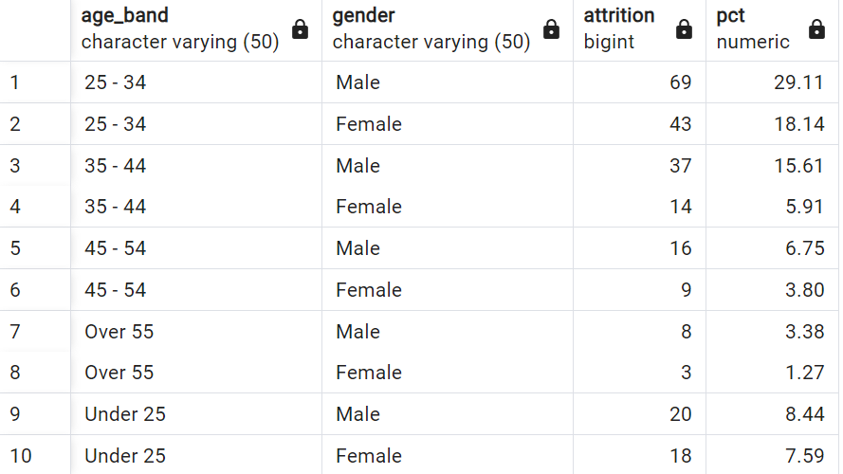

Job Satisfaction Rating:
- - Activating the cosstab() function
CREATE EXTENSION IF NOT EXISTS tablefunc;
- - Then
select *
from crosstab(
'select job_role, job_satisfaction, sum(employee_count)
from hrdata
group by job_role, job_satisfaction
order by job_role, job_satisfaction'
) as ct(job_role varchar(50), one numeric, two numeric, three numeric, four numeric)
order by job_role;
